**Quilting Patterns Medium**

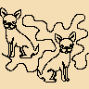

To the Dogs.png



Capri Feathers.png



Bamboo b2b.png



Bamboo.png



Baptist Fan.png



Baseball Meander.png

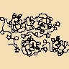

Bee.png

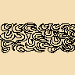

Blustery Breeze.png



Bunny and Stars.png



Butterflies and Loops.png



Caren Farnsworth.png



Cat Hat.png



Cat Lady.png



ClaudiaPfeil Butteryfly.png



ClaudiaPfeil Paradise 2.png



ClaudiaPfeil Paradise Isl.png



Clouds.png



Cogs.png



Curly Twirly Valentine.png



damask.png



Dragonfly Bed.png



Dutch Ship.png



EE Feathers 1.png



Eve.png



Field of Flowers.png



Feather Delight.png



Floral.png



Flower Bed.png



Football.png



Ghost.png



Grass.png



Holy.png



Joyful Pearls.png



Joyful.png

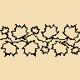

Maple Leaves.png



Monkeys.png

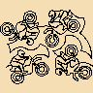

Motocross.png



PANT Hearts and Flowers.png

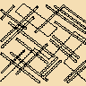

Pick up Sticks.png



PRPANT.png



PT Cats.png



Twister.png



Pumpkin Patch.png



Race Cars.png



Snowman.png



Soccer.png



SSDBDAE Flower.png



St Paddys Day.png



Star Trek.png

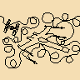

Star Wars.png



Teapots and Teacups.png



Trillium Leaves.png



Tulip.png

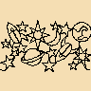

WF Beyond The Moon.png



Elegance.png



Flowing.png

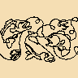

Fly Fishing.png



WF Kiddie Cars.png



WF Scrollwork.png

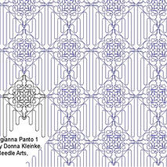

8799-Georgianna-PNT-1-jpg.JPG

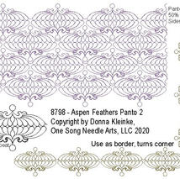

8798-Aspen-Fth-PNT-2-jpg.JPG

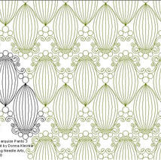

8790-Marquise-PNT-3-jpg.JPG

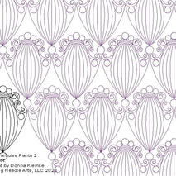

8789-Marquise-PNT-2-jpg.JPG

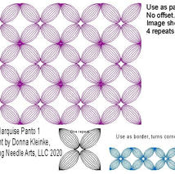

8788-Marquise-PNT-1-jpg.JPG

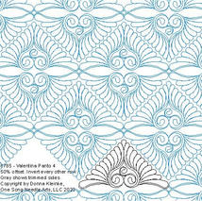

8785-Valentina-PNT-4-jpg.JPG



8784-Valentina-PNT-3-jpg.JPG

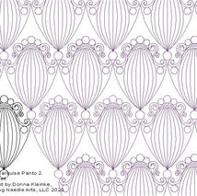

8789-Marquise-PNT-2-jpg.JPG



8782-Valentina-PNT-1-jpg.JPG



8783-Valentina-PNT-2-jpg.JPG

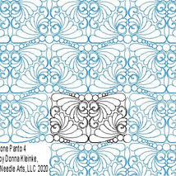

8781-Simone-PNT-4-jpg.JPG

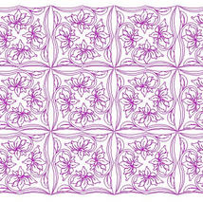

8771-Katies-Daisies-PNT-7-jpg.JPG



8784-Valentina-PNT-3-jpg.JPG

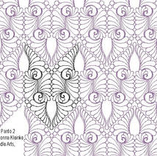

8779-Simone-PNT-2-jpg.JPG

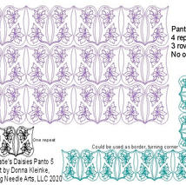

8769-Katies-Daisies-PNT-5-jpg.JPG

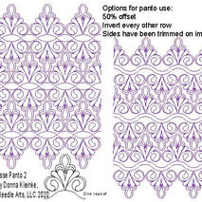

8762-Clarisse-PNT-2jpg.JPG

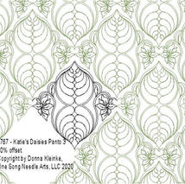

8767-Katies-Daisies-PNT-3-jpg.JPG

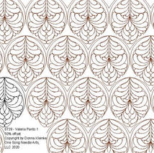

8739-Valeria-PNT-1-jpg.JPG

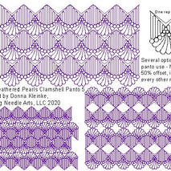

8755-Feather-Prl-Clamsh-PNT-5-jpg.JPG

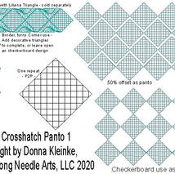

8756-Crosshatch-PNT-1-jpg.JPG

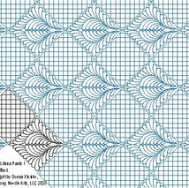

8754-Liliana-PNT-1-jpg.JPG

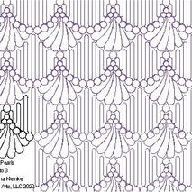

8752-Feather-Prl-Clamsh-PNT-3-jpg.JPG

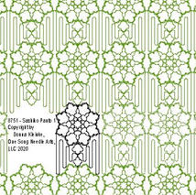

8751-Sashiko-PNT-1-jpg.JPG

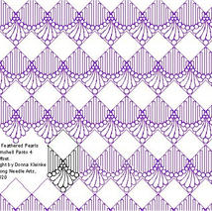

8753-Feather-Prl-Clamsh-PNT-4-jpg.JPG

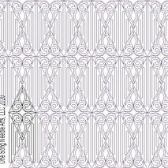

8750-Camilla-PNT-7-jpg.JPG

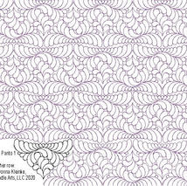

8743-Nerissa-PNT-1-jpg.JPG



8746-Gloria-Fth-PNT-4-jpg.JPG

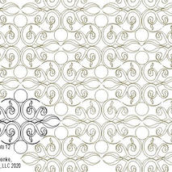

8734-Bittersweet-PNT-12-jpg.JPG

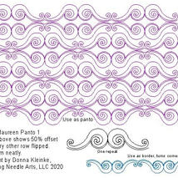

8724-Maureen-PNT-1-jpg.JPG

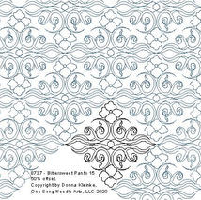

8737-Bittersweet-PNT-15-jpg.JPG

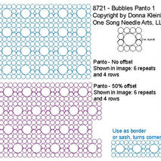

8721-Bubbles-PNT-1-jpg.JPG

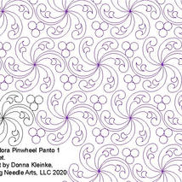

8716-AdoraPinwheel-PNT-1-jpg.JPG

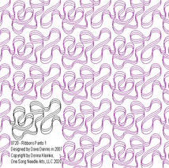

8720-Ribbons-PNT-1-jpg.JPG

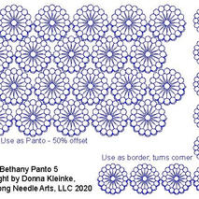

8718-Bethany-PNT-5-jpg.JPG

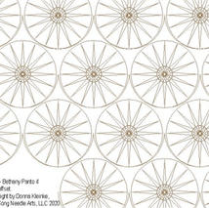

8715-Bethany-PNT-4-jpg.JPG

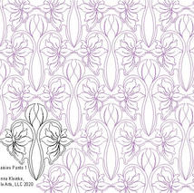

8706-Katies-Daisies-PNT-1-jpg.JPG

Out of gallery

**NB: Due to the amount of patterns not all have been tested so are subject to change of Density. IE: Medium to Dense**